|  |  |
| --- | --- |
| Business Analytics Skills for the Future-proofs Supply Chains - | **CASE STUDY**  **simulation modeling and analysis**  Authors:  Roman Gumzej |

**Content**

DESCRIPTION OF THE COMPANY 2

DECISION PROBLEM 7

TASK 1 8

TASK 2 9

TASK 3 11

# DESCRIPTION OF THE COMPANY

ETI is a home appliance producer and distributor (cp. Figure 1.1, extracted from the NetLogo simulation environment). The company has multiple production sites: main site in Slovenia (SI) as well as affiliate firms in Germany (DE), Poland (PL), Hungary (H), and Bosnia–Herzegovina (BIH). In addition to production sites, its gross-sales sites are situated in Russia (RUS), Ukraine (UKR), and Romania (RU). The production sites supply their own markets with finished products and each other with product components.

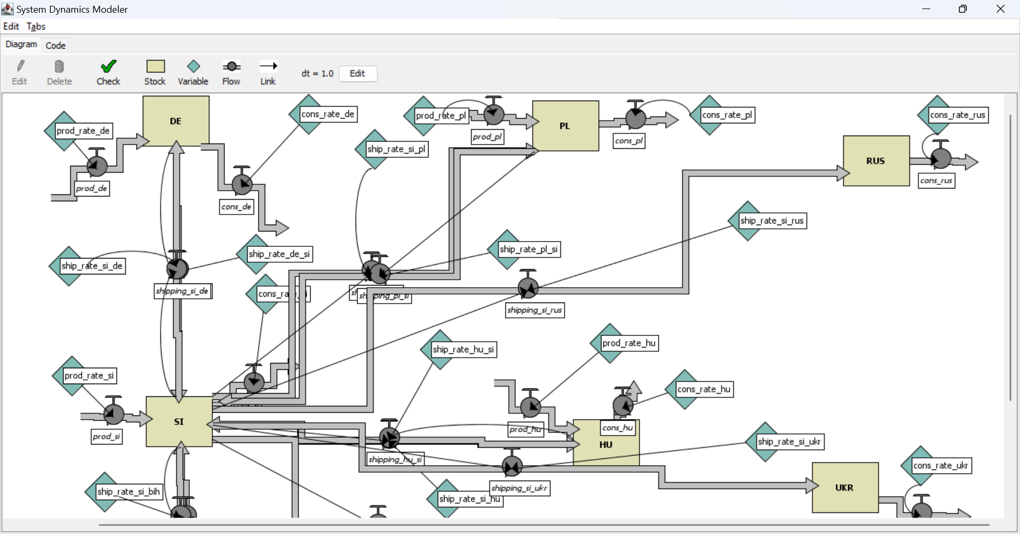

**Figure 1.1. ETI SC Layout**

Source: (Gumzej and Rakovska, 2020)

A simplified schematic of its production site in Slovenia (SI) (Figure 1.2, extracted from the JaamSim simulation environment) comprises a DES simulation model of variant production, where four different product lines are being produced. According to the production plan, some 10, 30, 40, 20% of product types 1, 2, 3, and 4, respectively, are being manufactured. After they have successfully passed their quality control, the finished products are transported from the production site to the finished products warehouse. Re-manufacturing defective products while still in production is an effective way to reduce both environmental impacts and manufacturing costs.

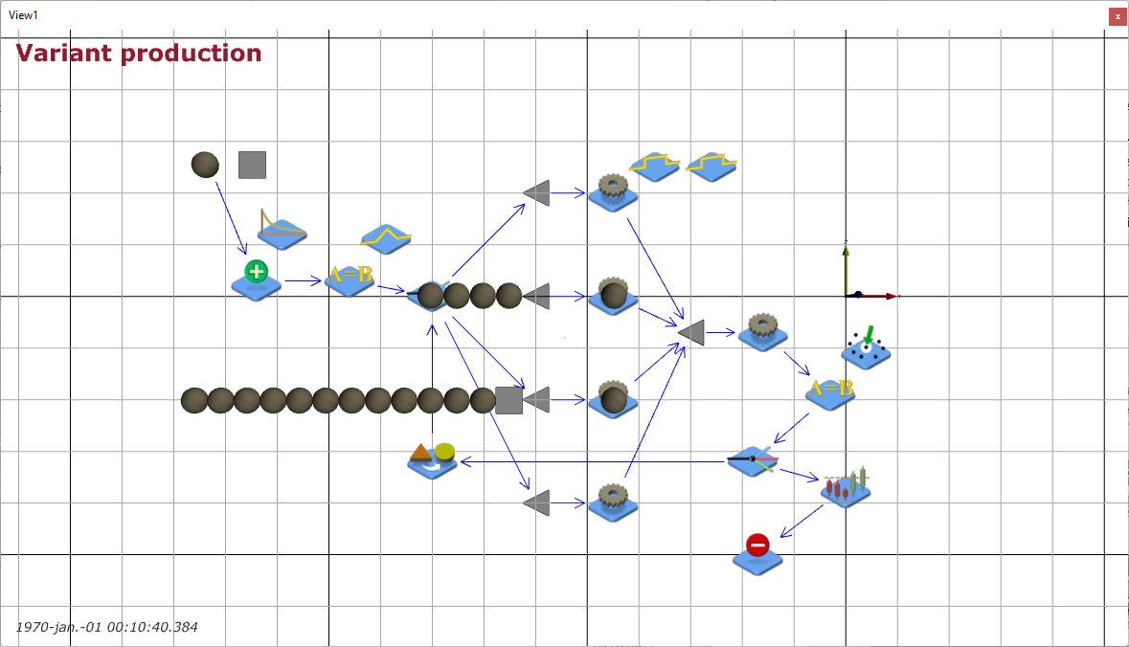

**Figure 1.2. ETI Variant production with quality control**

Source: (Gumzej and Rakovska, 2020)

The production site’s sales figures (Table 1.1), collected by the marketing department, comprise weekly sales data which helps the management to determine the busyest sites and their dominant products according to their sales portfolio. They have been used in the parameterisation of the supply chain and production site’s models.

**Table 1.1. Weekly sales data**

|  |  |  |  |  |  |
| --- | --- | --- | --- | --- | --- |
| **Date** | **Seller ID** | **Customer ID** | **Transaction ID** | **Product ID** | **Product Price** |
| 1.10.24 | 1 | 12 | 1 | 101 | 195,00 € |
| 1.10.24 | 1 | 12 | 1 | 102 | 45,00 € |
| 1.10.24 | 1 | 12 | 1 | 103 | 35,00 € |
| 1.10.24 | 2 | 14 | 2 | 104 | 55,00 € |
| 1.10.24 | 2 | 14 | 3 | 101 | 195,00 € |
| 2.10.24 | 3 | 15 | 4 | 105 | 85,00 € |
| 2.10.24 | 3 | 15 | 4 | 101 | 195,00 € |
| 2.10.24 | 3 | 15 | 4 | 103 | 35,00 € |
| 2.10.24 | 3 | 16 | 5 | 104 | 55,00 € |
| 2.10.24 | 1 | 17 | 6 | 101 | 195,00 € |
| 2.10.24 | 1 | 17 | 6 | 102 | 45,00 € |
| 2.10.24 | 1 | 17 | 6 | 105 | 85,00 € |
| 3.10.24 | 2 | 18 | 7 | 106 | 35,00 € |
| 3.10.24 | 2 | 18 | 7 | 107 | 65,00 € |
| 3.10.24 | 2 | 18 | 7 | 108 | 86,00 € |
| 3.10.24 | 4 | 19 | 8 | 105 | 85,00 € |
| 3.10.24 | 4 | 19 | 8 | 101 | 195,00 € |
| 3.10.24 | 4 | 19 | 8 | 103 | 35,00 € |
| 3.10.24 | 4 | 19 | 9 | 104 | 55,00 € |
| 4.10.24 | 5 | 20 | 10 | 105 | 110,00 € |
| 4.10.24 | 5 | 20 | 10 | 106 | 125,00 € |
| 4.10.24 | 5 | 20 | 10 | 104 | 55,00 € |
| 4.10.24 | 5 | 20 | 10 | 101 | 195,00 € |
| 4.10.24 | 1 | 21 | 11 | 102 | 45,00 € |
| 4.10.24 | 1 | 21 | 11 | 105 | 85,00 € |
| 4.10.24 | 1 | 21 | 12 | 106 | 35,00 € |
| 4.10.24 | 3 | 12 | 13 | 103 | 35,00 € |
| 4.10.24 | 3 | 12 | 13 | 104 | 55,00 € |
| 4.10.24 | 3 | 12 | 13 | 105 | 110,00 € |
| 4.10.24 | 3 | 12 | 13 | 101 | 195,00 € |
| 5.10.24 | 1 | 22 | 14 | 107 | 35,00 € |
| 5.10.24 | 1 | 22 | 14 | 108 | 25,00 € |
| 5.10.24 | 1 | 22 | 14 | 109 | 35,00 € |
| 5.10.24 | 2 | 23 | 14 | 110 | 95,00 € |
| 5.10.24 | 2 | 23 | 14 | 111 | 75,00 € |
| 5.10.24 | 3 | 24 | 15 | 112 | 125,00 € |
| 5.10.24 | 3 | 24 | 15 | 101 | 195,00 € |
| 5.10.24 | 3 | 24 | 15 | 102 | 45,00 € |
| 5.10.24 | 3 | 24 | 15 | 105 | 85,00 € |
| 5.10.24 | 1 | 25 | 16 | 106 | 35,00 € |
| 5.10.24 | 1 | 25 | 16 | 103 | 35,00 € |
| 5.10.24 | 1 | 25 | 16 | 104 | 55,00 € |
| 5.10.24 | 2 | 26 | 17 | 106 | 35,00 € |
| 6.10.24 | 3 | 11 | 18 | 105 | 85,00 € |
| 6.10.24 | 3 | 11 | 18 | 101 | 195,00 € |
| 6.10.24 | 3 | 11 | 18 | 103 | 35,00 € |
| 6.10.24 | 3 | 11 | 18 | 104 | 55,00 € |
| 6.10.24 | 4 | 12 | 19 | 105 | 110,00 € |
| 6.10.24 | 4 | 12 | 19 | 106 | 125,00 € |
| 7.10.24 | 2 | 27 | 20 | 107 | 65,00 € |
| 7.10.24 | 2 | 27 | 20 | 108 | 86,00 € |
| 7.10.24 | 2 | 27 | 20 | 105 | 85,00 € |
| 7.10.24 | 2 | 27 | 20 | 101 | 195,00 € |
| 7.10.24 | 1 | 28 | 21 | 103 | 35,00 € |
| 7.10.24 | 1 | 28 | 21 | 104 | 55,00 € |
| 7.10.24 | 1 | 28 | 21 | 106 | 35,00 € |

Source: (own)

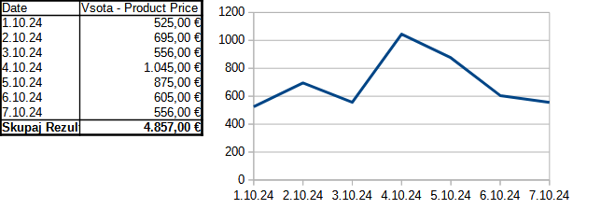**Figure 1.3. Sales statistics by weekday**

Sales statistics by weekday (Figure 1.3) enables production planning.

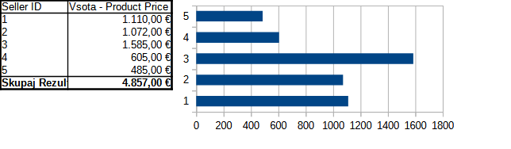

**Figure 1.4. Sales statistics by sales-office**

Sales statistics by company (Figure 1.4) determines the market requirements.

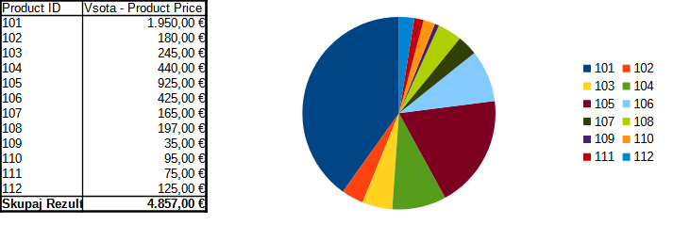**Figure 1.5. Sales statistics by product**

# DECISION PROBLEM

The problems in supply chain management pertain to all three levels of decision making.

* Strategic, where managers mainly decide on „what is to be done”;
* Tactical, where the management determines „how it can be done”;
* Operational, where management determines whether all resources are available and whether the capacities are sufficient.

The main questions are usually resolved in the following order:

1. Which products or locations should be promoted?
2. What is necessary to achieve this goal?
3. Which capacities and resources should be provided?
4. Are the envisaged plans being fulfilled?

The order resembles the Deming’s „plan-do-check-act” cycle, as discussed in the Introduction to Operations Research chapter:

1. Data collection and preparation
2. Business analytics
3. Capacity planning
4. Simulation modeling and analysis
5. Fulfilment

The tasks involved require knowledge from chapters Data management, Simulation Modeling and Analysis as well as Introduction to operations research.

This use case pertains to steps 3 and 4 – capacity planning, simulation modeling and analysis.

# TASK 1

Check the resources required and perform capacity planning. See, what production quantities fulfil the market requirements of the ETI supply chain?

Weekly sales statistics by number of products solds for the different ETI locations are:

* SI (production&sales): 18,
* DE (production&sales): 12,
* PL (production&sales): 16,
* H and BIH (production&sales): 6,
* RUS, UKR and RU (sales): 4.

|  |  |
| --- | --- |
|  | Fine tune the parameters to match Your case. |
|  | [ETI_big.nlogo](https://univerzamb-my.sharepoint.com/personal/roman_gumzej_um_si/Documents/Izobraževanje/Učbeniki%202024/BI/Chapter%204/ETI_big.nlogo) |

NOTES

# TASK 2

Parameterize the DES model to determine production times and volumes for location SI. Group product types accordingly to achieve a balanced load distribution.

Sales statistics by product (Figure 1.5) determines the products that are most sought for or represent a significant share in the ETI portfolio. According to these statistics, the production plan comprises some 10, 30, 40, 20% of product types 1, 2, 3, and 4, respectively:

* Type 1 (10%): 106, 107, 108, 109, 110, 111;
* Type 2 (30%): 105;
* Type 3 (40%): 101;
* Type 4 (20%): 102, 103, 104.

They are produced at the corresponding production lines 1-4 within each production branch of the ETI group. Each product type has a dedicated production line. Choosing a product type is induced by the triangular distribution between 1 and 4 with modulo at 3. According to sales statistics, the production orders are fulfilled according to the exponential distribution with 60-minute minimum and 480-minute maximum time between orders and a 120 minutes average interarrival time. The production of every single product takes 100–120 minutes according to the uniform distribution. After they are finalized, the products are checked for quality at a dedicated test site. The quality check takes 150 minutes. From the company’s experience, on average every 1 out of 10 products doesn’t pass inspection. Products of insufficient quality are transported back to the original production line. Their reprocessing takes 120–130 minutes according to the uniform distribution. The durations of production and quality inspection and reprocessing don’t depend on product type.

|  |  |
| --- | --- |
|  | Fine tune the model parameters to match Your case. |
|  | [Variant_Production.cfg](https://univerzamb-my.sharepoint.com/personal/roman_gumzej_um_si/Documents/Izobraževanje/Učbeniki%202024/BI/Chapter%204/Variant_Production.cfg) |

NOTES

# TASK 3

Analyze simulation results to make recommendations on production capacities:

* At which rates should the individual lines process production orders in order to fulfil demand and prevent bottlenecks?
* Is one quality control department enough?
* What is the production cycle length?
* How does the order of production-order fulfilment affect cycle length?

|  |  |
| --- | --- |
|  | Note the results and formulate recommendations accordingly. |
|  | [Variant_Production.cfg](https://univerzamb-my.sharepoint.com/personal/roman_gumzej_um_si/Documents/Izobraževanje/Učbeniki%202024/BI/Chapter%204/Variant_Production.cfg) |

NOTES

Business Analytics Skills for the Future-proofs Supply Chains -