|  |  |
| --- | --- |
| Business Analytics Skills for the Future-proofs Supply Chains - | **CASE STUDY**  **Operations research**  Authors:  Roman Gumzej |

**Content**

DESCRIPTION OF THE COMPANY 2

DECISION PROBLEM 7

TASK 1 8

TASK 2 9

TASK 3 10

# DESCRIPTION OF THE COMPANY

ETI is a home appliance producer and distributor (cp. Figure 1.1, extracted from the NetLogo simulation environment). The company has multiple production sites: main site in Slovenia (SI) as well as affiliate firms in Germany (DE), Poland (PL), Hungary (H), and Bosnia–Herzegovina (BIH). In addition to production sites, its gross-sales sites are situated in Russia (RUS), Ukraine (UKR), and Romania (RU). The production sites supply their own markets with finished products and each other with product components.

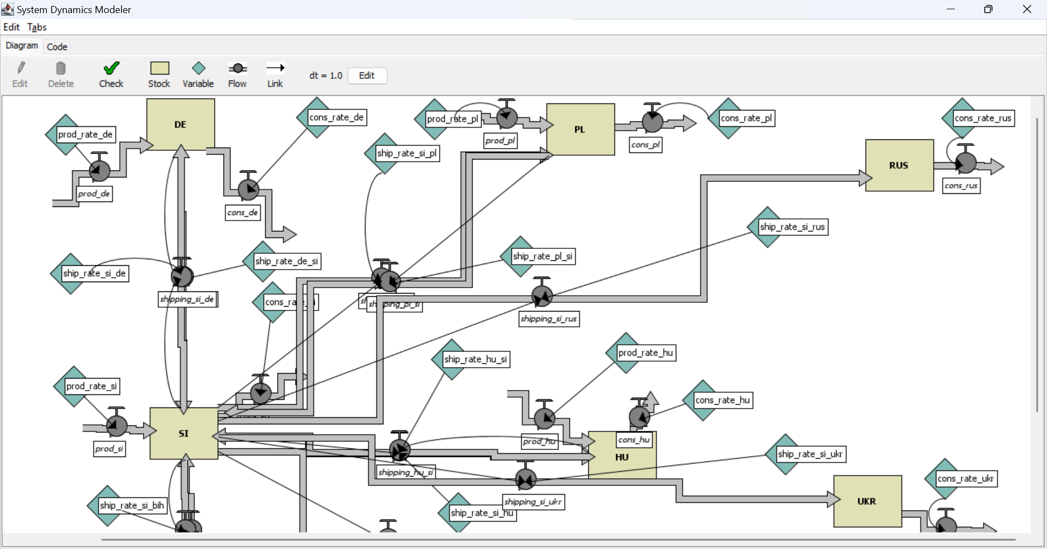

**Figure 1.1. ETI SC Layout**

Source: (Gumzej and Rakovska, 2020)

A simplified schematic of its production site in Slovenia (SI) (Figure 1.2, extracted from the JaamSim simulation environment) comprises a DES simulation model of variant production, where four main product lines are being produced. Each product type has a dedicated production line. After they are finalized, the products are checked for quality at a dedicated test site. Products of insufficient quality are transported back to the original production line. After they have successfully passed their quality control, the finished products are transported from the production site to the finished products warehouse. Re-manufacturing defective products while still in production is an effective way to reduce both environmental impacts and manufacturing costs.

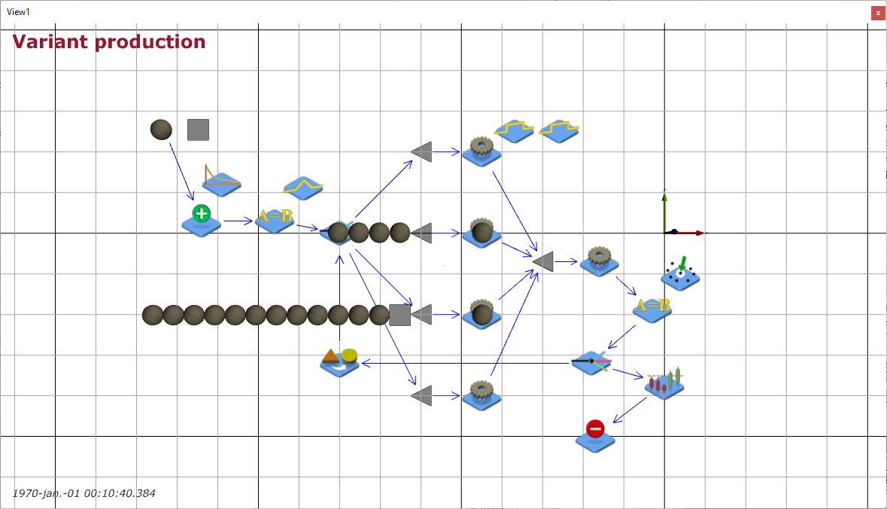

**Figure 1.2. ETI Variant production with quality control**

Source: (Gumzej and Rakovska, 2020)

The production site’s sales figures (Table 1.1), collected by the marketing department, comprise weekly sales data which helps the management to determine the busyest sites and their dominant products according to their sales portfolio. They have been used in the parameterisation of the supply chain and production site’s models.

**Table 1.1. Weekly sales data**

|  |  |  |  |  |  |
| --- | --- | --- | --- | --- | --- |
| **Date** | **Seller ID** | **Customer ID** | **Transaction ID** | **Product ID** | **Product Price** |
| 1.10.24 | 1 | 12 | 1 | 101 | 195,00 € |
| 1.10.24 | 1 | 12 | 1 | 102 | 45,00 € |
| 1.10.24 | 1 | 12 | 1 | 103 | 35,00 € |
| 1.10.24 | 2 | 14 | 2 | 104 | 55,00 € |
| 1.10.24 | 2 | 14 | 3 | 101 | 195,00 € |
| 2.10.24 | 3 | 15 | 4 | 105 | 85,00 € |
| 2.10.24 | 3 | 15 | 4 | 101 | 195,00 € |
| 2.10.24 | 3 | 15 | 4 | 103 | 35,00 € |
| 2.10.24 | 3 | 16 | 5 | 104 | 55,00 € |
| 2.10.24 | 1 | 17 | 6 | 101 | 195,00 € |
| 2.10.24 | 1 | 17 | 6 | 102 | 45,00 € |
| 2.10.24 | 1 | 17 | 6 | 105 | 85,00 € |
| 3.10.24 | 2 | 18 | 7 | 106 | 35,00 € |
| 3.10.24 | 2 | 18 | 7 | 107 | 65,00 € |
| 3.10.24 | 2 | 18 | 7 | 108 | 86,00 € |
| 3.10.24 | 4 | 19 | 8 | 105 | 85,00 € |
| 3.10.24 | 4 | 19 | 8 | 101 | 195,00 € |
| 3.10.24 | 4 | 19 | 8 | 103 | 35,00 € |
| 3.10.24 | 4 | 19 | 9 | 104 | 55,00 € |
| 4.10.24 | 5 | 20 | 10 | 105 | 110,00 € |
| 4.10.24 | 5 | 20 | 10 | 106 | 125,00 € |
| 4.10.24 | 5 | 20 | 10 | 104 | 55,00 € |
| 4.10.24 | 5 | 20 | 10 | 101 | 195,00 € |
| 4.10.24 | 1 | 21 | 11 | 102 | 45,00 € |
| 4.10.24 | 1 | 21 | 11 | 105 | 85,00 € |
| 4.10.24 | 1 | 21 | 12 | 106 | 35,00 € |
| 4.10.24 | 3 | 12 | 13 | 103 | 35,00 € |
| 4.10.24 | 3 | 12 | 13 | 104 | 55,00 € |
| 4.10.24 | 3 | 12 | 13 | 105 | 110,00 € |
| 4.10.24 | 3 | 12 | 13 | 101 | 195,00 € |
| 5.10.24 | 1 | 22 | 14 | 107 | 35,00 € |
| 5.10.24 | 1 | 22 | 14 | 108 | 25,00 € |
| 5.10.24 | 1 | 22 | 14 | 109 | 35,00 € |
| 5.10.24 | 2 | 23 | 14 | 110 | 95,00 € |
| 5.10.24 | 2 | 23 | 14 | 111 | 75,00 € |
| 5.10.24 | 3 | 24 | 15 | 112 | 125,00 € |
| 5.10.24 | 3 | 24 | 15 | 101 | 195,00 € |
| 5.10.24 | 3 | 24 | 15 | 102 | 45,00 € |
| 5.10.24 | 3 | 24 | 15 | 105 | 85,00 € |
| 5.10.24 | 1 | 25 | 16 | 106 | 35,00 € |
| 5.10.24 | 1 | 25 | 16 | 103 | 35,00 € |
| 5.10.24 | 1 | 25 | 16 | 104 | 55,00 € |
| 5.10.24 | 2 | 26 | 17 | 106 | 35,00 € |
| 6.10.24 | 3 | 11 | 18 | 105 | 85,00 € |
| 6.10.24 | 3 | 11 | 18 | 101 | 195,00 € |
| 6.10.24 | 3 | 11 | 18 | 103 | 35,00 € |
| 6.10.24 | 3 | 11 | 18 | 104 | 55,00 € |
| 6.10.24 | 4 | 12 | 19 | 105 | 110,00 € |
| 6.10.24 | 4 | 12 | 19 | 106 | 125,00 € |
| 7.10.24 | 2 | 27 | 20 | 107 | 65,00 € |
| 7.10.24 | 2 | 27 | 20 | 108 | 86,00 € |
| 7.10.24 | 2 | 27 | 20 | 105 | 85,00 € |
| 7.10.24 | 2 | 27 | 20 | 101 | 195,00 € |
| 7.10.24 | 1 | 28 | 21 | 103 | 35,00 € |
| 7.10.24 | 1 | 28 | 21 | 104 | 55,00 € |
| 7.10.24 | 1 | 28 | 21 | 106 | 35,00 € |

Source: (own)

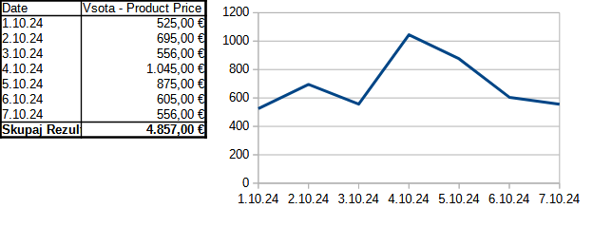**Figure 1.3. Sales statistics by weekday**

Sales statistics by weekday (Figure 1.3) enables production planning.

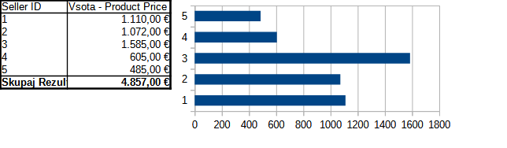

**Figure 1.4. Sales statistics by sales-office**

Sales statistics by company (Figure 1.4) determines the market requirements.

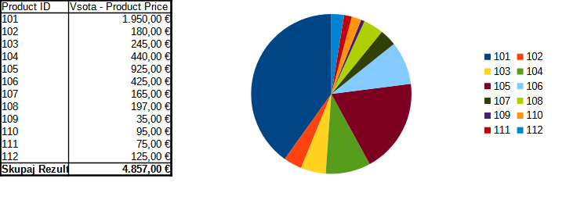**Figure 1.5. Sales statistics by product**

Sales statistics by product (Figure 1.5) determines the products that are most sought for or represent a significant share in the ETI portfolio.

# DECISION PROBLEM

The problems in supply chain management pertain to all three levels of decision making.

* Strategic, where managers mainly decide on „what is to be done”;
* Tactical, where the management determines „how it can be done”;
* Operational, where management determines whether all resources are available and whether the capacities are sufficient.

The main questions are usually resolved in the following order:

1. Which products or locations should be promoted?
2. What is necessary to achieve this goal?
3. Which capacities and resources should be provided?
4. Are the envisaged plans being fulfilled?

The order resembles the Deming’s „plan-do-check-act” cycle, as discussed in the Introduction to Operations Research chapter:

1. Data collection and preparation
2. Business analytics
3. Capacity planning
4. Simulation modeling analysis
5. Fulfilment

The tasks involved require knowledge from chapters Data management, Simulation Modeling and Analysis as well as Introduction to operations research.

This use case pertains to steps 2 and 6 – analytics and fulfilment.

# TASK 1

Perform business analytics on the collected data using pivot tables. The results should resemble the data and graphs, as given in the problem description. Determine:

* The busyest days;
* The busiest locations;
* The critical products.

What else could You determine from the collected data?

|  |  |
| --- | --- |
|  | Use the results from the Data management use-case. |
|  | [BA (2024).ods](https://univerzamb-my.sharepoint.com/personal/roman_gumzej_um_si/Documents/Izobraževanje/Učbeniki%202024/BI/Chapter%206/BA%20(2024).ods) |

NOTES

# TASK 2

Analyze simulation results to make recommendations on production capacities:

* Is the grouping of products to product types appropriate?
* Is the distribution of production facilities appropriate?
* Are there any bottlenecks and how could they be avoided?

Note the results and formulate recommendations accordingly.

|  |  |
| --- | --- |
|  | See the results from the Simulation modeling and analysis use-case. |
|  | [ETI_big.nlogo](https://univerzamb-my.sharepoint.com/personal/roman_gumzej_um_si/Documents/Izobraževanje/Učbeniki%202024/BI/Chapter%204/ETI_big.nlogo)  [Variant_Production.cfg](https://univerzamb-my.sharepoint.com/personal/roman_gumzej_um_si/Documents/Izobraževanje/Učbeniki%202024/BI/Chapter%204/Variant_Production.cfg) |

NOTES

# TASK 3

Devise an action plan the management should fulfil on the strategic, tactical as well as operational levels according to the DFSS paradigma. Use the results from the previous tasks.

What have You learned? What information do You still miss?

|  |  |
| --- | --- |
|  | Use the results from the use-cases to chapters 3, 4 and 6. |

NOTES

Business Analytics Skills for the Future-proofs Supply Chains -